Linköping University

**Time constant comparison of a DC motor system**

**Report author:** Jonathan Edvardsson

**Laboratory partner:** Thomas Indrias

**Instructor:** Kjell Karlsson

**Course:** TNG022 - Modelling and Simulation

**Date of experiment:** November 29, 2018

**Date of submission:** December 11, 2018

**1. Introduction**

The contents of this report is based on a laboratory session at Linköping University which aim was to model and simulate the system of a DC motor of type M-586-0585.

A DC motor can be divided into two parts, an electrical part and a mechanical part. The behaviour and role of each part in the system is identified by the corresponding time constant. Time constants are usually specified in the data sheet specification that follows with the system. Although, there are alternative methods used to define the time constants. These methods include simulating a model of the DC motor using simulation software tools or analytically calculating the time constant using mathematical operations.

The aim of this report is to analyse the three different methods mentioned above and compare the time constants for each part in the system and the system as a whole. The scope of this report is limited to not take the computation methods used by the simulation software into account.

**2. Method and Materials**

**2.1 Prequisities**

Figure 1 shows a schematic picture of the DC motor of type M-586-0585 used in the laboratory session. The schematic picture clearly illustrates both the electrical and the mechanical part of the system. Using this schematic picture, a bond graph model of the system was developed. This bond graph is illustrated in Figure 2.

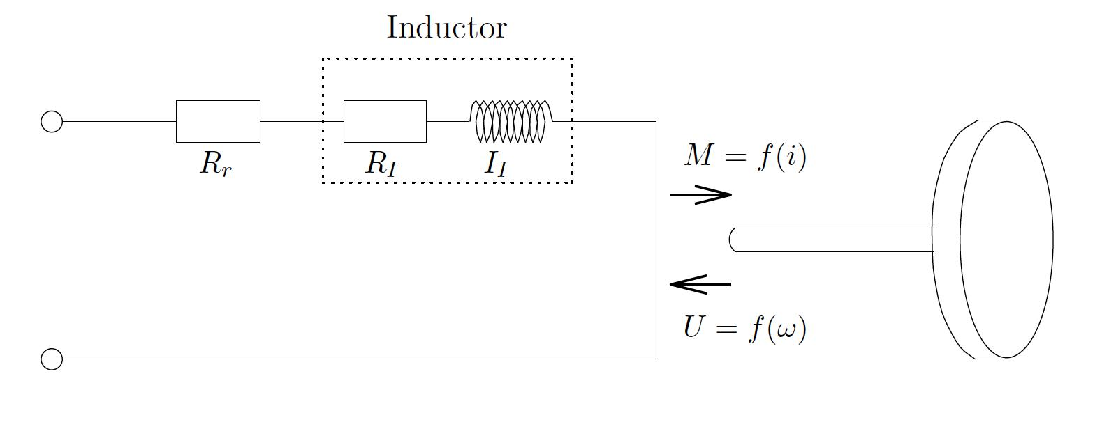

***Figure 1:*** *Schematic picture of DC motor type M-586-0585*

1!

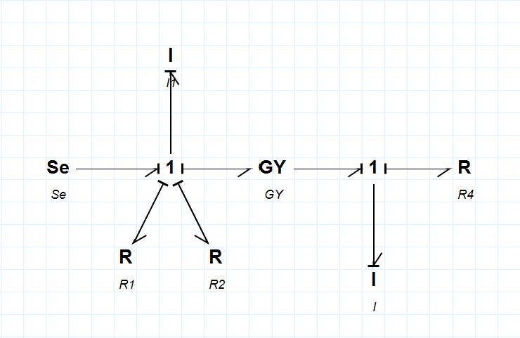

***Figure 2:*** *Bond-graph system description of the given DC motor*

Table 1 shows the notations of the three time constants analysed in this report. The first method used for defining these is reading the data sheet specification that followed with the motor. This method will not be thoroughly covered in this section of the report since it only includes reading values from the data sheet specification of the DC motor. This section will thus be focusing on the explanation of the two remaining methods - analysis using simulation and analytical calculation. An important thing to note is that each method used can not define all three time constants alone. The mechanical time constant !*m* can not be retrieved from the data sheet specification and !*tot* can not be analytically calculated since it can not be solved as a first order system.

***Table 1:*** *Time constants notations for each part of the DC motor system*



|  |  |
| --- | --- |
| **Time constant type** | **Notation** |
| **Electrical** | !*e* |
| **Mechanical** | !*m* |
| **Whole system** | !*tot* |

**2.2 Data sheet specification**

The data sheet specification for the DC motor that was modelled during the laboratory session is displayed in the Figure A.1 in the Appendix. The sheet specifies the electrical time constant and the time constant of the whole system. These were read and documented for later comparison with the time constant values defined using the alternative methods.

!2

**2.3 Simulation**

A block diagram model was created using the bond graph in order to simulate the system. The model, illustrated in Figure 3, was developed using Simulink blocks and then implemented in Simulink -

a computer programming environment used to model, simulate and analyse dynamic mechatronic systems. Table 2 displays the values used as input parameters, which were retrieved from the data sheet specification of the DC motor.

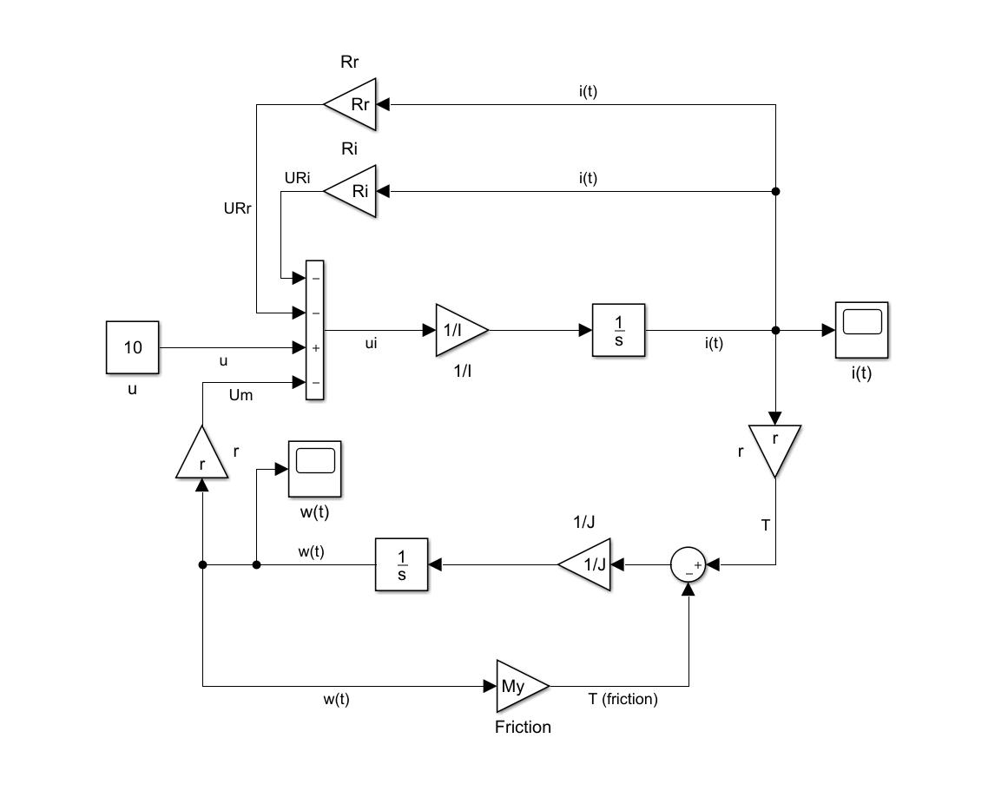

***Figure 3:*** *Block-diagram system description of the given DC motor using Simulink blocks*

***Table 2:*** *Constants for the DC motor parameters, retrieved from the data sheet specification*



|  |  |
| --- | --- |
| **Variable** | **Constant** |
| *R***!***I* | !0.8 Ω |
| *R***!***r* | !0.35 Ω |
| *I***!** | !3.39 ⋅ 10−3 *H* |
| *I* |  |
| **!** | !0.056 |
|  |  |
| *J***!** | !3.88 ⋅ 10−5 *k g m*2 |
| **!** | !1.19 ⋅ 10−4 *Nm s* /*r a d* |

!3

The block diagram model was divided into two parts, in order to simulate the system and compute the time constants for each part. All three time constants were defined by plotting the step response for each part of the system and then defining the rise time. The rise time of a system is defined by analysing the time it takes for the signal to reach 63% of a certain value, which in this case is the final value where the step response converges. See Figure 4 below for an illustration of this approach.

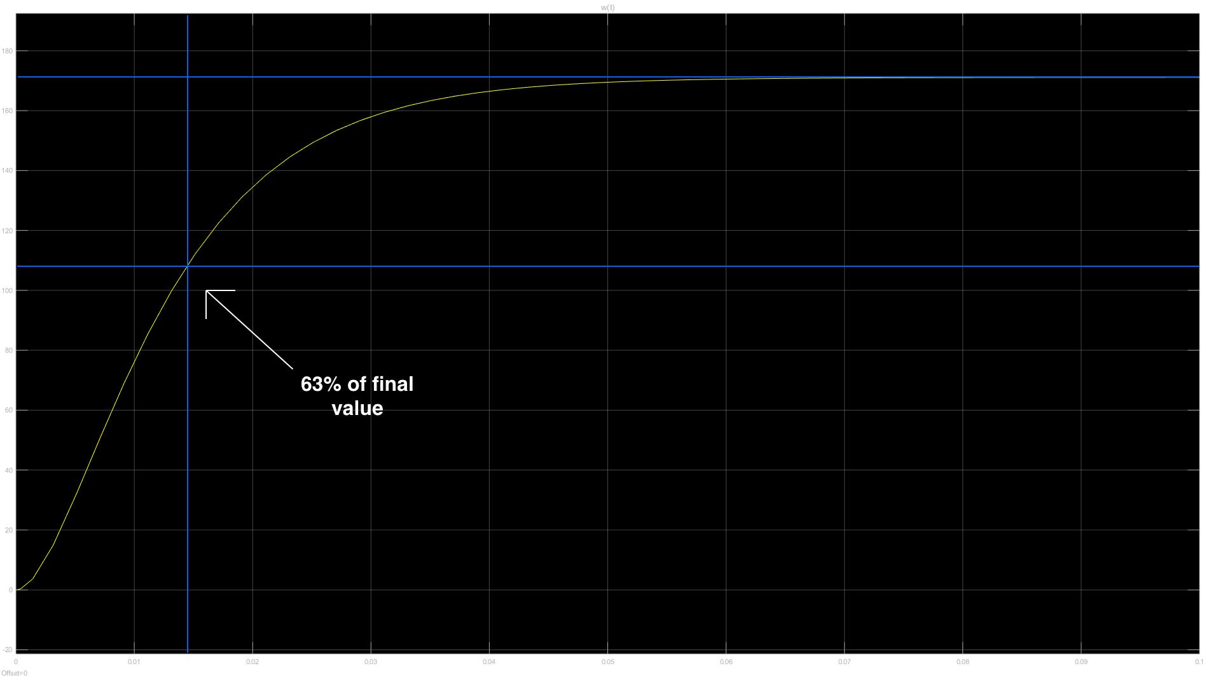

***Figure 4:*** *Illustration of defining rise time using the step response of the system.*

*The yellow line is the plotted step response.*

To define the time constant of the whole system a simulation was run using the entire block diagram of the DC motor (i.e. with both the electrical and mechanical part being connected). The step response !*ω*(*t*) was plotted and the time constant was defined by computing the rise time using the steps explained above in this section.

A similar approach was used to define the time constant of the electrical part. When analysing the electrical part, the mechanical part of the system was neglected and therefore not implemented in the Simulink block diagram model. The step response to be plotted and analyzed was in this case !*i*(*t*).

The time constant for the mechanical part was also defined correspondingly. The two differences being that the implemented model instead neglected the electrical part of the whole system model and the plotted step response once again being !*ω*(*t*).

!4

**2.4 Analytical calculation**

Just like the bond graph model illustrated in Figure 1, the system could be divided into an electrical and a mechanical subsystem. To calculate the time constants for each subsystem the first step was to utilize the transfer function for first order systems. The same transfer function appeals to both subsystems of the DC motor and is displayed in Eq. 1.

|  |  |  |  |  |
| --- | --- | --- | --- | --- |
|  |  | |  |  |
| !*G* (*s*) = | *k* | | (1) |  |
| *τs* + 1 |  |  |

where:

* = Time constant of the subsystem

!*k* = Constant

By using the equations from the state-space system description of the bond graph one gets the equations displayed in Eq. 2 and Eq. 3 below.

!*G* (*s*) = *I*(*s*)

*e* *U*(*s*)



!*G* (*s*) = *ω*(*s*)

*m* *M*(*s*)



where:

!*Ge*(*s*) = Transfer function for the electrical subsystem  !*Gm*(*s*) = Transfer function for the mechanical subsystem

(2)

(3)

The next step was to substitute the variables in Eq. 2 and Eq. 3 with the corresponding equations defined for the bond-graph system description. These equations are displayed in Table 3 on the following page.

!5

***Table 3:*** *Equations for all parts of the bond-graph system description*



|  |  |  |  |  |  |  |  |
| --- | --- | --- | --- | --- | --- | --- | --- |
| **Parameter** | **Equation** | | |  |  |  |  |
| **!***Se* | ! |  |  |  |  |  |  |
| **!***S* | ! *I* |  |  | *R* | *R* | *m* |  |
| 1 |  |  |  | *I* | *r* |  |  |
| **!***S*2 | !*TJ* = *T* − *Tμ* | | | |  |  |  |
| *R***!**: *R* | !*UR* = *RI* ⋅ *i* (*t* ) | | | |  |  |  |
| *I* | *I* |  |  |  |  |  |  |
| *R***!**: *R* | !*UR* = *Rr* ⋅ *i* (*t* ) | | | |  |  |  |
| *r* | *r* |  |  |  |  |  |  |
| *R***!**: *μ* | !*Tμ* = *μ* ⋅ *ω* (*t* ) | | | |  |  |  |
|  |  | 1 | ⋅ ∫ | *t* |  |  |  |
| *I***!**: *II* | !*i*(*t* ) = | *II* | *uI* (*τ* ) *d τ* | |  |  |
|  |  | 1 | ⋅ ∫ | *t* |  |  |  |
| *I***!**: *J* | !*ω* (*t* ) = | *J* | *TJ* (*τ* ) *d τ* | |  |  |
| **!***T*(*t*) | !*r* ⋅ *i* (*t* ) | |  |  |  |  |  |
|  |  | |  |  |  |  |  |
| **!** *m* | !*r* ⋅ *ω* (*t* ) | |  |  |  |  |  |

This operation yields the two equations displayed in Eq. 4 and Eq. 5.

|  |  |  |  |  |  |  |  |  |  |  |  |  |  |
| --- | --- | --- | --- | --- | --- | --- | --- | --- | --- | --- | --- | --- | --- |
| !*Ge*(*s*) = |  | 1 | |  | ⋅ |  |  |  |  | 1 | | (4) |  |
| *RI* + *Rr* | | | |  | *II* |  |  |  |  |  |
|  |  | ( |  |  |  | ) ⋅ *s* + 1 | |  |
|  |  | *R* + | *R* | |  |  |
|  |  |  |  |  |  |  | *I* |  | *r* | | | |  |
| !*G* (*s*) = 1 | | ⋅ |  |  | 1 | |  |  |  | (5) | | |  |
|  |  |  |  |  |  |  |  |
| *m* | *μ* |  |  | ( *J* ) ⋅ *s* + 1 | | | | | |  |  |  |  |
|  |  |  |  | *μ* |  |  |  |  |  |  |  |  |  |



The final step was to use the transfer function in Eq.1 to define the time constants for each subsystem. By observing Eq. 4 and Eq. 5 one gets the time constant equations seen in Eq. 6 and Eq. 7. Using the values displayed in Table 2 the time constant values for both parts of the system could be obtained.

|  |  |  |  |  |
| --- | --- | --- | --- | --- |
| !*τe* = |  | *II* | (6) |  |
| *R* + *R* | |  |
|  |  | *Ir* |  |  |
| !*τm* = | | *J* | (7) |  |
| *μ* |  |



!6

**3. Results**

The results obtained by defining the time constants using all three methods can be seen in Table 4 below.

***Table 4:*** *The results of calculated time constant values for each method*



|  |  |  |  |
| --- | --- | --- | --- |
| **Time constant** | **Data sheet spec.** | **Analytical** | **Simulation** |
|  |  |  |  |
| **!***e* | 2.95 | 2.94 | 2.97 |
| **!***m* | N/A | 326 | 324.13 |
| **!***tot* | 10.2 | N/A | 14.31 |

**4. Discussion**

The results showed that the time constant value for the electrical part, !*e*, varies very little regardless of the method used to define it. Compared to the value computed using the simulation software, the analytically calculated time constant was closer to the value specified on the data sheet specification. Assuming that the value specified on the data sheet is most correct, the analytical method had an error of 1 ms (0.34%) while the one defined using simulation had an error of 2 ms (0.68%). Although, these differences can depend on various error sources including human error, lab environment disturbances, value rounding and the algorithm used by the simulation tool when computing. Compared to the mechanical time constant, !*e* is also vastly smaller. This is the case because of the mechanical parts not being as reactive to system changes as the electrical part.

The mechanical time constant, !*m*, could only be calculated using analytical methods and simulation software. The results showed a small difference of 1.87 ms (0.57%) between the values. With a 4.11 ms (40.29%) difference, the time constant calculated using simulation differed vastly from the value specified on the data sheet specification. An important thing to note is that there is no information specified on how the values in the data sheet specification were obtained. Therefore, it is hard to compare what the error might depend on. A few possible errors are the ones mentioned in the paragraph above. Since the mechanical time constant was not specified in the data sheet it is hard to know whether the analytically calculated or the simulated value is closest to the real case. Despite both values being very similar, factors like rust, temperature and friction might differentiate the real system time constant from the time constant values calculated in Table 4.

An important thing to note is that compared to analytical methods, simulation software is better at analysing complex systems. It is of course possible to do this using analytical methods, but a simulation will in this case be far superior in terms of computation speed and flexibility when modelling and analysing a system. Another great benefit of the simulation method is that one could analyse all time constants of the system.

!7

**5. Conclusion**

Albeit the methods having their own benefits and weaknesses, the conclusion was that the recommended approach would be to use simulation software when modelling systems and analysing time constants. Compared to the alternative methods not being able to calculate all three time constants, the simulation software handled this problem with ease. Benefits like modelling flexibility and computation speed make this method more suitable when analysing systems, especially ones that are rather complex. Therefore, analytical methods are more suitable for validating computations performed when simulating. This approach increases the possibilities of discovering errors that might be caused by faulty model implementations of the system.

!8

**Appendix**

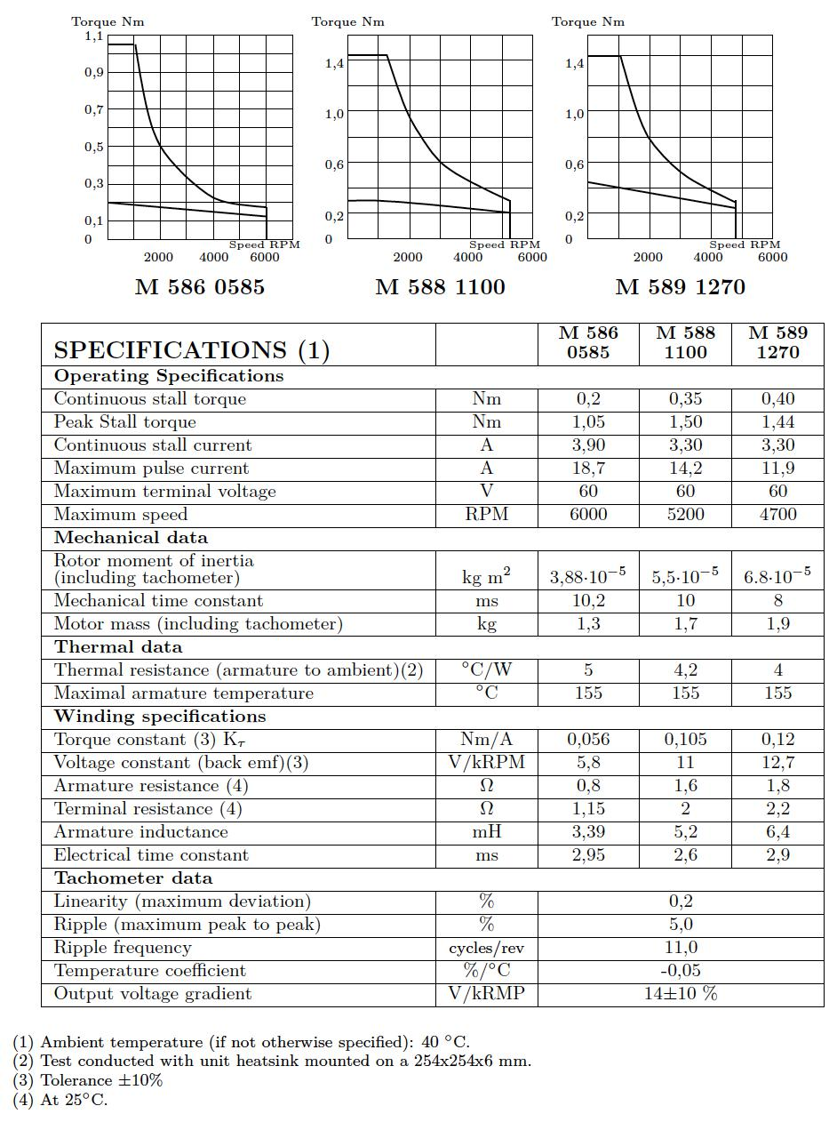

***Figure A.1:*** *Data sheet specification for the DC motor,* *the type relevant to this report being M-586-0585.*